- Please check that all required objects on BL_3NF Layer (CE_...) have been created.
- Grant all required privileges to BL_CL (Cleansing Layer). Check ‘Knowledge_Base.docx’ and ‘Naming_Conventions.docx’
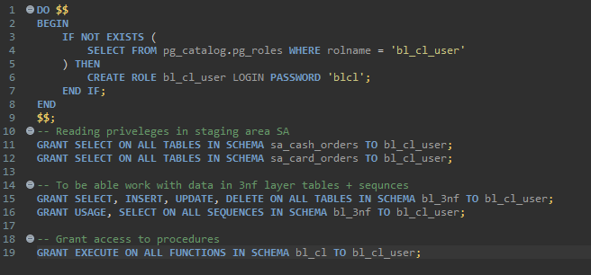
- Create functions and procedures on BL_CL (one procedure = one table) to load data in 3NF layer tables.
- Every procedure must be repeatable, and no modifications should occur after multiple consecutive runs.
  - CommonProcedures.sql - 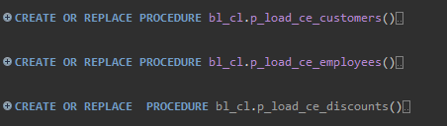
  - LocationProcedures.sql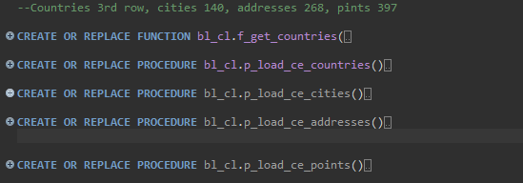
  - CardProcedures.sql only for card src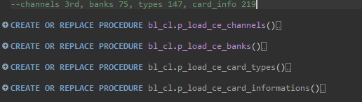
  - Productprocedures.sql 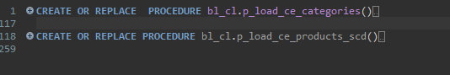
For load into products used
temp table to get distinct data with first date
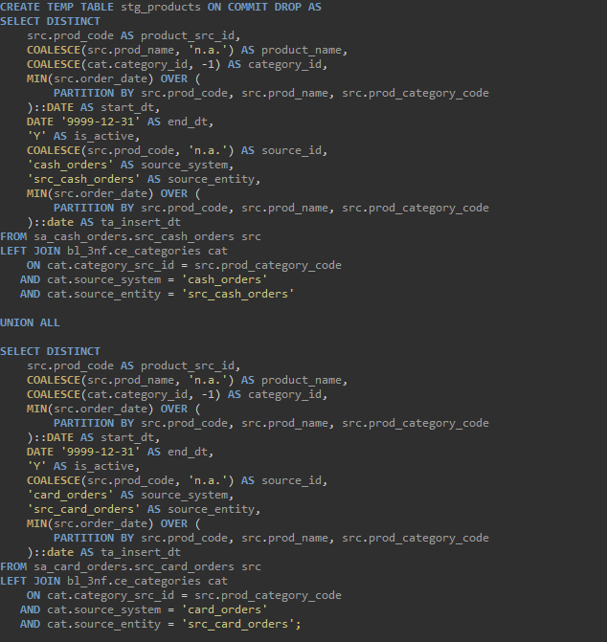
then update if we have cnhages
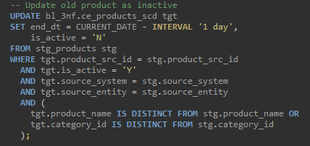
And then insertion with partition, partitioning helps find the latest version of each product in the staging table(temp table) based on insert_dt.
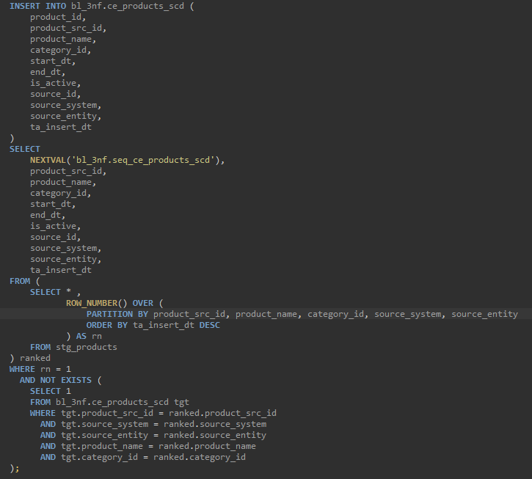
- Use For Loop over query result (One or more functions).
- Use Function returns table (or setoff type) (One or more functions).
- CREATE OR REPLACE FUNCTION bl_cl.f_get_countries(
- p_source TEXT,
- p_entity TEXT,
- p_table TEXT
- )
- RETURNS TABLE (
- country_src_id TEXT,
- country_name TEXT,
- source_system TEXT,
- source_entity TEXT
- ) AS
- $$
- DECLARE
- v_sql TEXT;
- BEGIN
- v_sql := format(
- 'SELECT
- point_country::TEXT AS country_src_id,
- COALESCE(point_country, ''n.a.'')::TEXT AS country_name,
- %L::TEXT AS source_system,
- %L::TEXT AS source_entity
- FROM (
- SELECT DISTINCT point_country
- FROM %s
- WHERE point_country IS NOT NULL
- ) sub',
- p_source, p_entity, p_table
- );

- RETURN QUERY EXECUTE v_sql;
- END;
- $$ LANGUAGE plpgsql;
Function that returns table realized in countries table.
Loop also
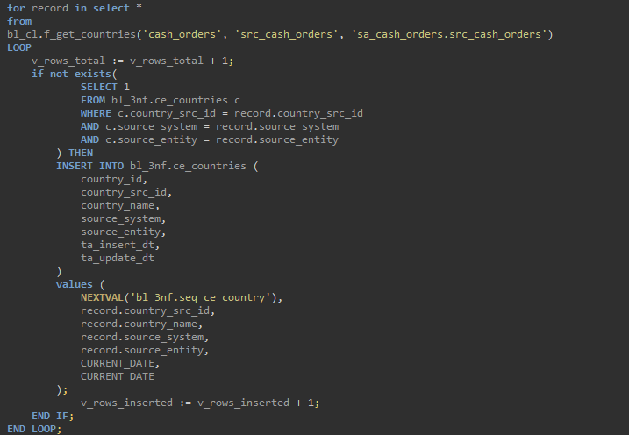

- In every procedure use exception block.
- EXCEPTION
- WHEN OTHERS THEN
- CALL bl_cl.p_log_event(
- 'load_ce_countries',
- 0,
- 0,
- 'FAIL',
- SQLERRM
- );
- RAISE;

Add Logging functionality
Required points:
- Create a centralized table for logging data storing
- Think about what columns will be useful for see the logging information about your procedure (at least: datetime, procedure_name, number of rows affected, text message to log (such as indicating successful loading or an error code).
- Create a separate procedure in your database to insert appropriate logging information.
- CREATE TABLE IF NOT EXISTS bl_cl.etl_log (
- log_id SERIAL PRIMARY KEY,
- log_dt TIMESTAMP DEFAULT CURRENT_TIMESTAMP,-- date of log
- procedure_name TEXT NOT NULL,
- rows_inserted INTEGER DEFAULT 0,
- rows_affected_skipped INTEGER DEFAULT 0,-- skipped rows (e.g. null keys)
- status TEXT NOT NULL,
- message TEXT-- optional description or error
- );

- --procedure to insert data into log table from load procedures
- CREATE OR REPLACE PROCEDURE bl_cl.p_log_event(
- p_procedure_name TEXT,
- p_rows_inserted INTEGER,
- p_rows_affected INTEGER,
- p_status TEXT,
- p_message TEXT
- )
- LANGUAGE plpgsql
- AS
- $$
- BEGIN
- INSERT
- INTO
- bl_cl.etl_log (
- procedure_name,
- rows_inserted,
- rows_affected_skipped,
- status,
- message
- )
- VALUES (
- p_procedure_name,
- p_rows_inserted,
- p_rows_affected_skipped,
- p_status,
- p_message
- );
- END;

- $$;
So, we will get info about insertions, affected rows detailed info will be in message
for example for scd2 will updated information
for others skipped data

Some results
Products scd
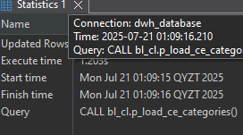
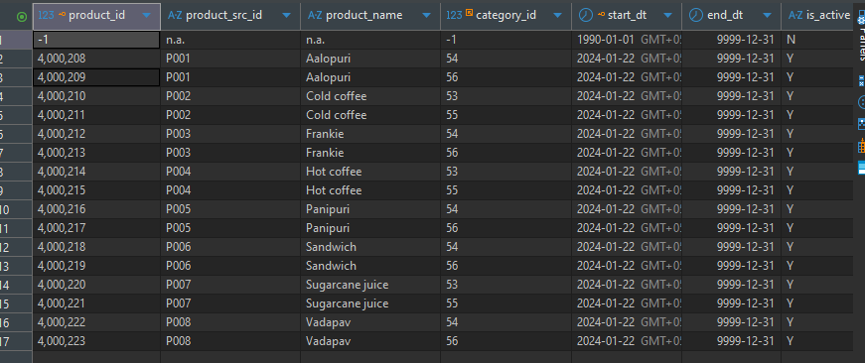
CALL bl_cl.p_load_ce_products_scd();
INSERT INTO sa_cash_orders.src_cash_orders –no access to insert so need to use postgres
(order_id, order_date, prod_code, prod_name, prod_category_code, prod_category, prod_price, quantity, discount_percentage, discount_date, payment_amount, payment_type, point_name, point_address, point_city, point_country, cust_first_name, cust_last_name, cust_phone_number, employee_first_name, employee_last_name, employee_dob, employee_personal_id, employee_phone_number)
VALUES('ORD-500002', '2025-03-29', 'P007', 'Sugarcane juice3', 'C001', 'Beverages', '29.0', '5', '0', NULL, '145', 'Cash', 'Balaji_1', 'Satpaeva 127', 'Atyrau', 'Kazakhstan', 'Tyler', 'Duffy', '525-287-3036x77950', 'Alex', 'Ivanov', '1985-03-15', 'EMP005', '87010000005');
SELECT * FROM bl_3nf.ce_products_scd c ;

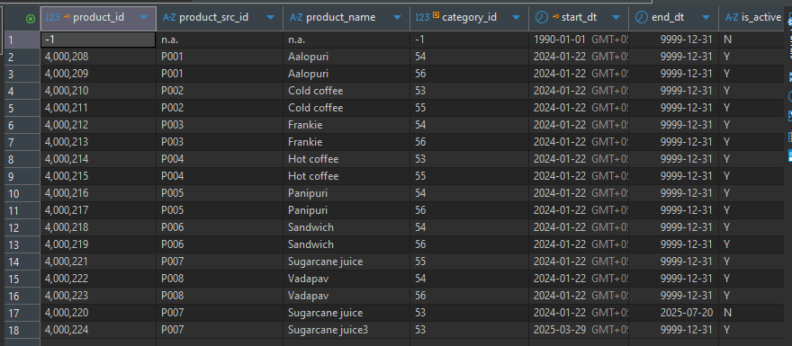
Called all procedures
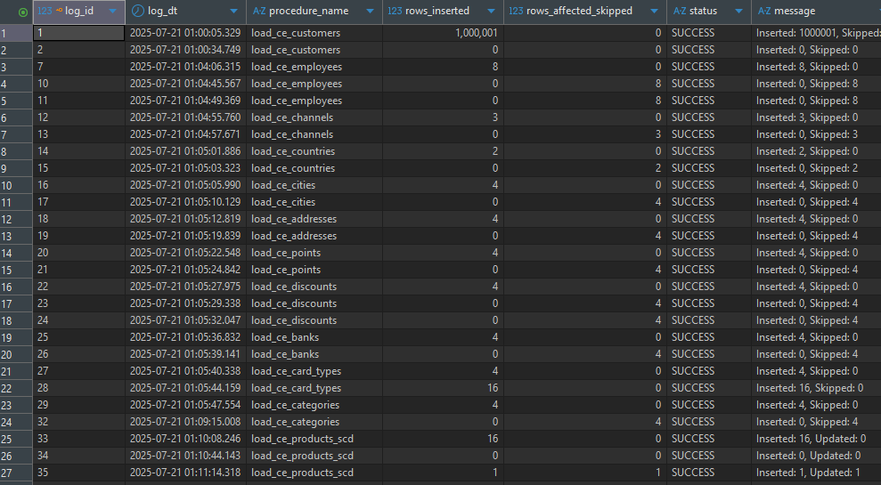

Some screens
